The effect of exercise on vascular health in chronic kidney disease: a systematic review of randomised controlled trials

Supplementary Material

# Bias bar plots

Figure S1: Barplot summarizing bias in studies reporting PWV. Size of bars adjusted for weight of study in meta-analysis 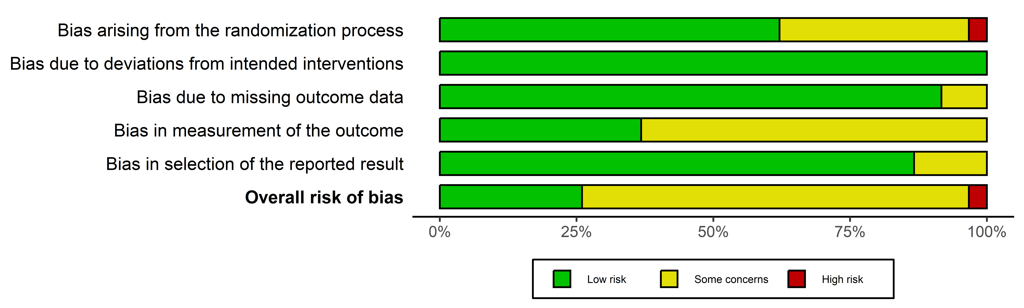

Figure S2: Barplot summarizing bias in studies reporting AIx. Size of bars adjusted for weight of study in meta-analysis 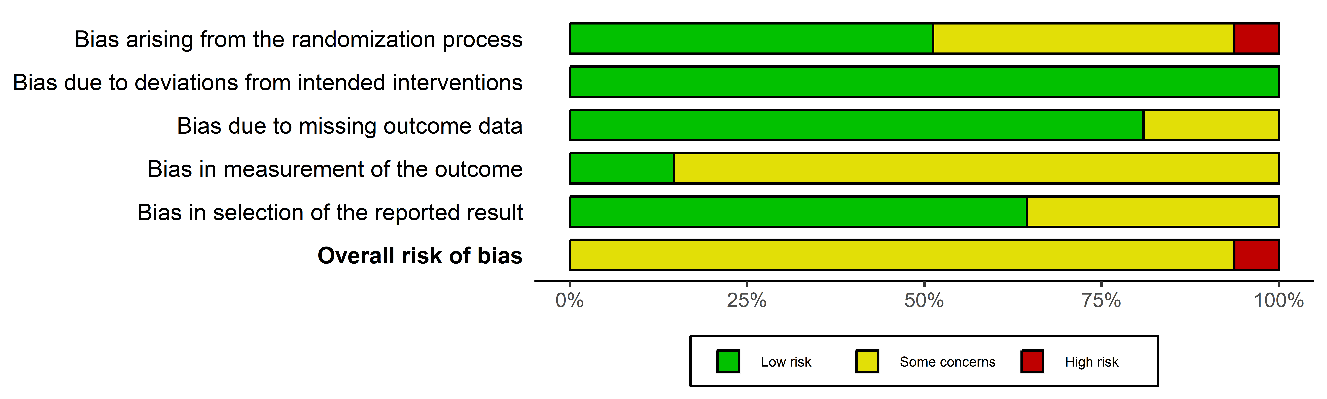

Figure S3: Barplot summarizing bias in studies reporting measures of endothelial function. Size of bars adjusted for weight of study in meta-analysis 